**Denbies**

**Reason for the location of Denbies**

* The slopes are south facing so get the sun and are protected from cold Northerly winds- good for growing grapes
* The chalk geology means the soil is well drained- perfect for the growing of vines as they do not like to be water logged
* The soil type is like that in the champagne region, so sparkling wine grapes grow well here.
* Near to Dorking which provides the labour and business
* Near to good transport route like the M25 for access and exporting goods

**Inputs, Processes, Outputs and Feedback/Linkages**

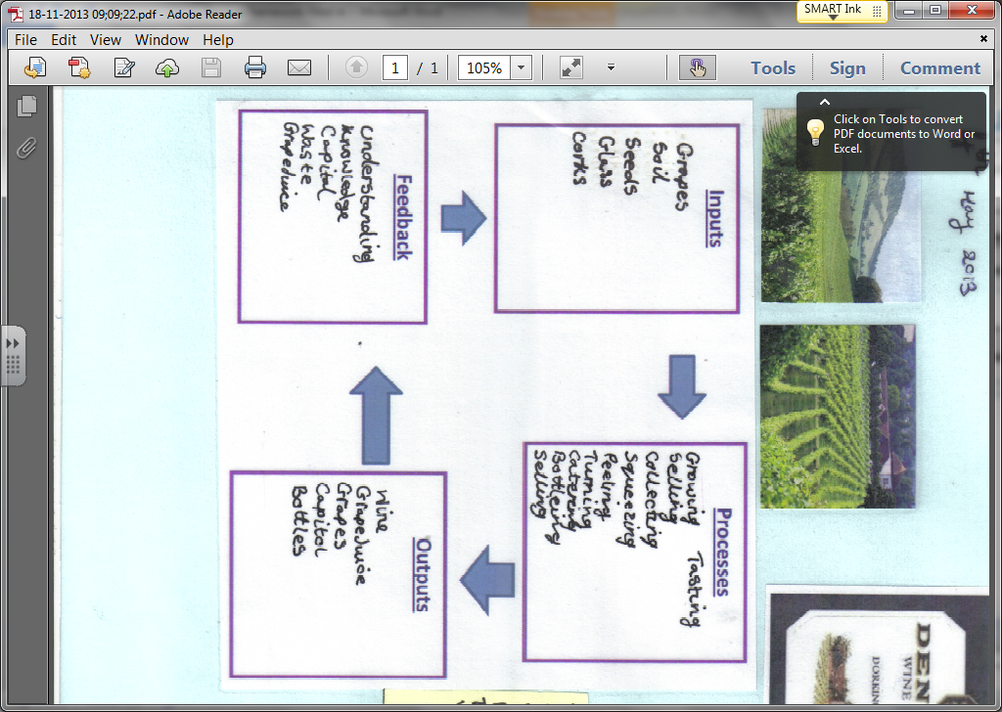

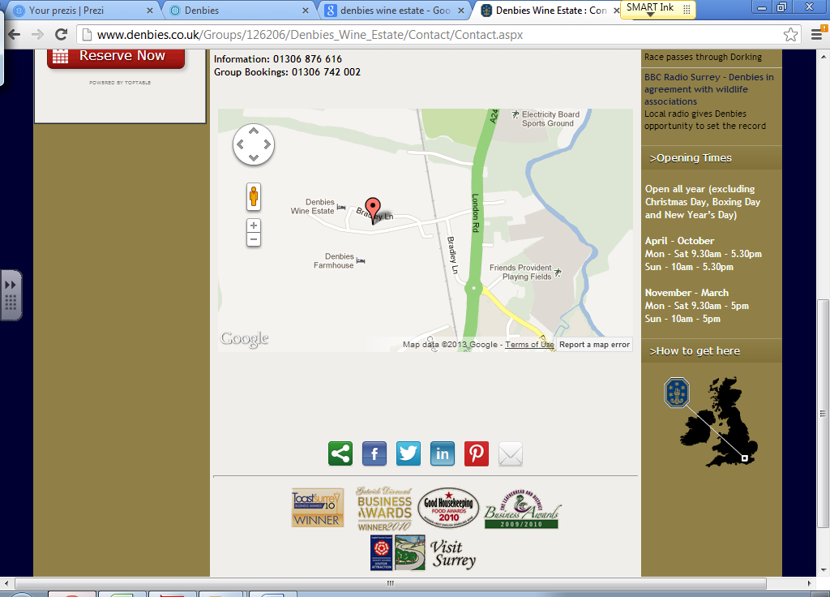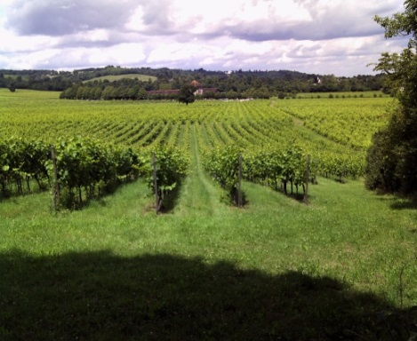

**Positives to the local area**

* Provides jobs for the local area which boost the economy
* People who have shops, restaurants and hotels in the local area may benefit from increased business from people in the area
* Local roads are maintained to ensure people and goods can get in and out of Denbies
* Walking route and footpaths are maintained in the site

**Negatives to the local area**

* Pollution can be caused by the big burners that are used to keep the vines warm
* Soil and fertilisers and leech into the river below causing eutrophication and clog up the river
* Congestion can be a problem at peak times and large lorries can take up the roads